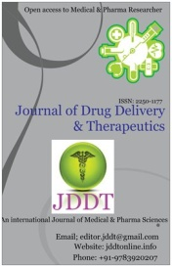
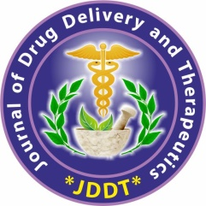
Available online on 15.12.2019 at http://jddtonline.info
Journal of Drug Delivery and Therapeutics
Open Access to Pharmaceutical and Medical Research
© 2011-18, publisher and licensee JDDT, This is an Open Access article which permits unrestricted non-commercial use, provided the original work is properly cited
Open Access Research Article
Method development and validation for simultaneous estimation of methotrexate and curcumin in Bulk Drug by using RP-HPLC
* Ankalgi Amar Deep, Chaudhary Nitin Kumar, Kaushal Pooja, Ashawat Mahendra Singh
Laureate Institute of Pharmacy, VPO Kathog, Jawalamukhi, Himachal Pradesh-176031, India

ABSTRACT
Curcumin is the natural herb that shows effect in the treatment of cancer and rheumatoid arthritis and methotrexate is well known anticancer and anti-rheumatoid drug. Literature survey reveals that there was no method available for the selected drug combination. So, here an attempt has been made to develop simple, rapid and economic method for simultaneous estimation of methotrexate and curcumin in bulk drug by using RP-HPLC method. The percentage assay from optimized method was found to be 99.68% and 99.76% for methotrexate and curcumin respectively. The proposed method was validated for linearity, accuracy, precision and robustness according to ICH guidelines and were found to be within the standard range.
Keywords: RP- HPLC, methotrexate, Linearity, anticancer


Article Info: Received 13 Oct 2019; Review Completed 25 Nov 2019; Accepted 30 Nov 2019; Available online 15 Dec 2019
Cite this article as:
Ankalgi AD, Chaudhary NK, Kaushal P, Ashawat MS, Method development and validation for simultaneous estimation of methotrexate and curcumin in Bulk Drug by using RP-HPLC , Journal of Drug Delivery and Therapeutics. 2019; 9(6-s):127-135 http://dx.doi.org/10.22270/jddt.v9i6-s.3775
*Address for Correspondence:
Ankalgi Amar Deep, Laureate Institute of Pharmacy, VPO Kathog, Jawalamukhi, Himachal Pradesh-176031, India

- INTRODUCTION:
Methotrexate is an antineoplastic agent come under the classification of antimetabolites. Methotrexate is used alone or in combination with other anticancer agents in the treatment of breast cancer, epidermoid cancers of the head and neck, advanced mycosis fungicides and lung cancer, particularly squamous cell and small cell types. ^{[1]}
Curcumin is a polyphenol that shows anticancer activity and curcumin that is obtained from the Curcuma longa is a natural herb so they do not show side effects. Turmeric contains the three form of curcuminoids i.e. curcumin, desmethoxycurcumin, and bisdemethoxycurcumin . It is used as an anti-inflammatory, antioxidant, and antinociceptive agents. In addition, treatment of degenerative eye conditions and metabolic disorders.^{[2]}
Both drugs show effect in the treatment of cancer as well as rheumatoid arthritis. In addition, literature survey reveals that there was no method available for the selected drug combination. It aids to develop simple, rapid and economic method for simultaneous estimation of methotrexate and curcumin in bulk drug by RP-HPLC method.^{[3to 6]}
Methotrexate
Curcumin

- EXPERIMENTAL WORK^{[7-10]}:
2.1 Materials and Method:
2.1.1 Instrument
The lambda max and iso-absorptive point were determined by using double beam UV-spectrophotometer, Lab India. Method development and validation studies were carried out by using Shimadzu prominence LC 20 AD.
2.1.2 Selection of wavelength
The sensitivity of HPLC method that uses UV detection depends upon proper selection of detection wavelength. An ideal wavelength is the one that gives good response for the drugs that are to be detected. For the selection of wavelength 10 µg/ml concentration of methotrexate and 10 µg/ml of curcumin used and overlain spectrum is taken. Curcumin and methotrexate was prepared in 50: 50 of 2% acetic acid and methanol from this solution iso-absorptive point was obtained that gives the idea about wavelength selection the final selected wavelength is 274 nm. However , RP-HPLC optimized wavelength was found to be 360nm . (Figure-1)

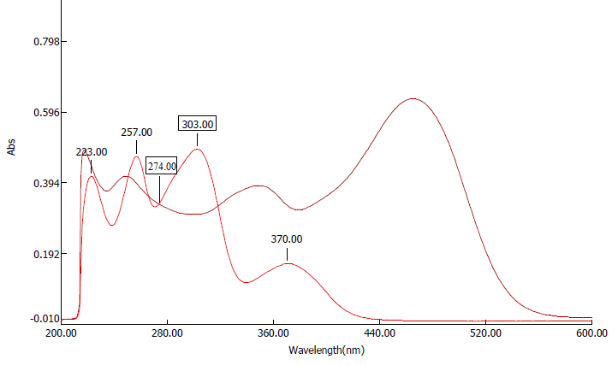
Figure-1

2.1.3 Selection of chromatographic conditions
Chromatographic separation was achieved at ambient temperature on a reversed phase high performance liquid chromatographic using mobile phase consisting of acetonitrile and 2% acetic acid. The mobile phase was pumped at a rate of 1 ml/min. The detector wavelength was set at 360nm and run time was 15 minutes.
To optimize the chromatographic conditions, the effect of chromatographic variables such as mobile phase and flow rate were studied. The resulting chromatograms were recorded and the chromatographic responses were measured.
2.1.4 Column
For the chromatographic separation of drugs the column of Shimadzu octadecylsilane Hypersil (ODS) C₁₈ having length of 150 ×4.6 mm, with particle size of 5 µ was used.
2.2 Preparation of standard stock solution:
2.2.1 Methotrexate standard stock solution
Standard methotrexate 50 mg was weighed and transferred to a 100 ml volumetric flask and dissolved in HPLC grade methanol: 2% acetic acid in ratio of 50:50. The contents were mixed and volume was made up to the mark with solvent to give a solution containing 500 µg/ml concentrations.
2.2.3 Curcumin standard stock solution
Standard curcumin 50 mg was weighed and transferred to a 100 ml volumetric flask and dissolved in HPLC grade acetonitrile. The contents were mixed and volume was made up to the mark with solvent to give a solution containing 500 µg/ml concentrations.
2.3 Final optimized Trail :
2.3.1 Chromatographic conditions
The mobile phase consisting of 55:45 of ACN: 2% acetic acid was used and absorbance was measured at 360nm.
2.3.2 Preparation of the mobile phase
The mobile phase was prepared by filtration and ultra-sonication of ACN and 2% Acetic acid. 2% Acetic acid is prepared by mixing 2ml of HPLC grade acetic acid in water for HPLC in a 100ml volumetric flask.
Chromatogram of methotrexate and curcumin was shown in figure 1 to4.

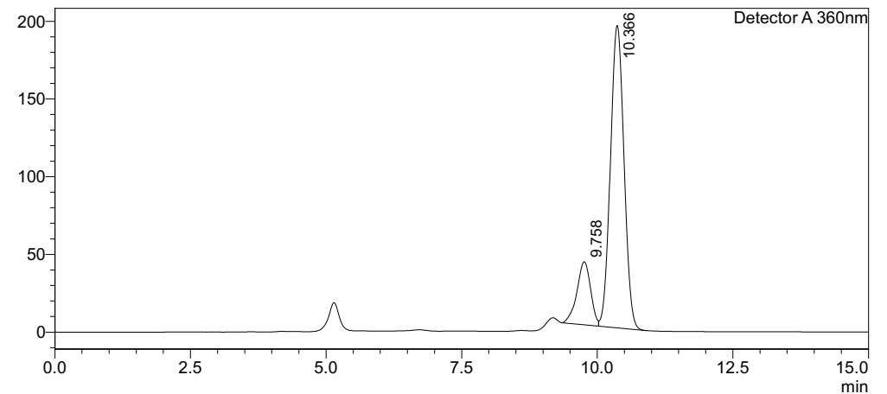
Figure-2 Chromatogram of curcumin at wavelength 360nm

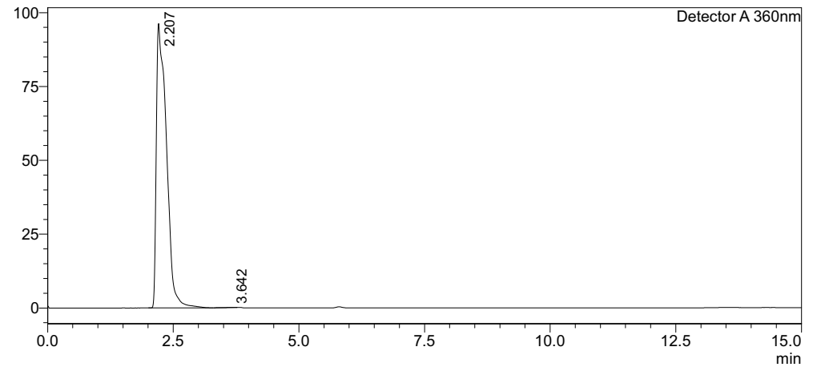
Figure :3 Chromatogram of methotrexate at wavelength 360nm

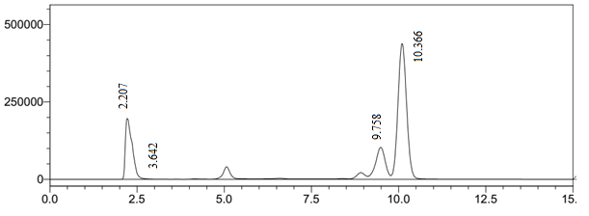
Figure :4 Chromatogram of both drugs at 360nm

2.4 Validation of developed method^{(11 to17]}
2.4.1 Linearity curve for methotrexate
From the standard methotrexate stock solution, the volume of 2, 2.4, 2.8, 3.2, 3.6, 4 mL was pipetted out and transferred to 10 mL volumetric flask. Then volume was made up to the mark having concentration of 100, 120, 140, 160, 180, 200 µg/mL. The sample injection was given at a time interval of 10 minutes with a run time of 15 minutes. The linearity was obtained in selected conc. Ranges. The results are shown in figure 5 and table 1
Table 1: Result of linearity curve of methotrexate at wavelenght 360nm
Sr.No. | Conc(µg/ml) | Area (µvolt sec)
 | 100 | 1356739
 | 120 | 1670474
 | 140 | 1941435
 | 160 | 2220076
 | 180 | 2446944
 | 200 | 2720070

Figure: 5. Linearity curve of methotrexate at 360 nm
2.4.2 Linearity curve of method for determination of curcumin
From the standard curcumin stock solution, the volume of 1.5, 2, 2.5, 3, 3.5, 4 mL was pipetted out and transferred to 10 mL volumetric flask. Then volume was made up to the mark having concentration of 75, 100, 125, 150, 175, 200 µg/mL. The sample injection was given at a time interval of 10 minutes with a run time of 15 minutes. The linearity was obtained in selected conc. Ranges. The results are shown in figure 6 and table 2.
Table 2: Result of linearity curve of curcumin at wavelenght 360nm
Sr.No. | Conc(µg/ml) | Area (µvolt sec)
 | 75 | 2602548
 | 100 | 3499465
 | 125 | 4458077
 | 150 | 5438626
 | 175 | 6580110
 | 200 | 7544843

Figure: 6. Linearity curve of curcumin at 360 nm

2.4.3 Accuracy
Accuracy is the closeness of the test results obtained by the method to the true value. Accuracy may often express in terms of percent recovery of assay of known amount of analyte added. Recovery studies were carried out by addition of standard drug to the sample at 3 different levels of spiking i.e. 80%, 100% and 120% of the actual amount taking into consideration percentage purity of added bulk drug samples.^{[18]}(Table-3 &4)
2.4.5 Drug recovery
$$\% Drug recovery=\frac{Amount found}{Amount added}×100$$
$$Amount found=\frac{Mean test abs.}{Mean standard abs.}×standard conc.$$
$$Amount added=\frac{Weigth}{Volume}$$

Table: 3 % Drug Recovery of methotrexate at wavelength 360 nm
Sr.  No | Amt. of sample added | Amt. of drug added | Amount recovered  (mg/mL) |  |  | Mean | S.D | %RSD | %Drug recovery
Sr.  No | Amt. of sample added | Amt. of drug added | 1. | 2. | 3.
1. | 50 | 30 | 79.3 | 79.6 | 79.8 | 79.57 | 0.252 | 0.316 | 99.462
2. | 50 | 50 | 99.6 | 99.5 | 99.8 | 99.63 | 0.153 | 0.153 | 99.630
3. | 50 | 70 | 119.6 | 119.3 | 119.9 | 119.60 | 0.300 | 0.251 | 99.666
Mean of % RSD |  |  |  |  |  |  |  | 0.245
Mean of % Drug recovery |  |  |  |  |  |  |  |  | 99.586

Table: 4 % Drug Recovery of curcumin at wavelength 360 nm
Sr.  No | Amt. of sample added | Amt. of drug added | Amount recovered  (mg/mL) |  |  | Mean | S.D | %RSD | %Drug recovery
Sr.  No | Amt. of sample added | Amt. of drug added | 1. | 2. | 3.
1. | 50 | 30 | 79.5 | 79.9 | 79.8 | 79.73 | 0.208 | 0.261 | 99.662
2. | 50 | 50 | 99.8 | 99.7 | 99.7 | 99.73 | 0.058 | 0.058 | 99.730
3. | 50 | 70 | 119.8 | 119.8 | 119.7 | 119.77 | 0.058 | 0.048 | 99.808
Mean of % RSD |  |  |  |  |  |  |  | 0.122
Mean of % Drug recovery |  |  |  |  |  |  |  |  | 99.733

2.4.6 Precision
The precision of an analytical method is the degree of closeness of agreement between a series of measurements obtained from the multiple sampling of the same sample. Precision include repeatability, inter and intraday precision and reproducibility ^{[19]}.
2.4.6.1 Interday and intraday precision
Interday and intraday precision of concentration 125, 150, 175µg/ml for curcumin and 140, 160, 180µg/ml for methotrexate was prepared and data was obtained. 3 replicates were prepared for 3 days. The results were shown in table 5 to 7 for methotrexate and curcumin.

Table: 5. Intraday precision of methotrexate and curcumin at 360 nm
Drug | Methotrexate |  |  | Curcumin
Concentration | 140µg/ml | 160µg/ml | 160µg/ml | 125µg/ml | 150µg/ml | 175µg/ml
Area
  1941402
  1941421
  1941440
  2220060
  2220102
  2220117
  2446940
  2446967
  2446987
  4458001
  4458020
  4458060
  5438501
  5438540
  5438560
  6580101
  6580117
  6580137
Mean | 1941421 | 2220093 | 2446964.67 | 4458027 | 5438534 | 6580118
SD | 19.000 | 29.547 | 23.586 | 30.116 | 30.006 | 18.037
%RSD | 0.000979 | 0.001331 | 0.00096 | 0.000676 | 0.000552 | 0.000274

Table:6 Interday Precision of Methotrexate
Day | Day1 |  |  | Day2 |  |  | Day3
concentration | 140µg/ml | 160µg/ml | 180µg/ml | 140µg/ml | 160µg/ml | 180µg/ml | 140µg/ml | 160µg/ml | 180µg/ml
Area | 2059856  2059864  2059877 | 2154251  2154260  2154276 | 2289566  2289575  2289587 | 1998864  1998823  1998888 | 2058564  2058674  2058685 | 2298663  2298684  2298620 | 2065653  2065660  2065682 | 2165684  2165670  2165653 | 2354653  2354667  2354686
Mean | 2059865.67 | 2154262.33 | 2289576 | 1998858.33 | 2058671 | 2298655.67 | 2065665 | 2165669 | 2354668.67
SD | 10.599 | 12.662 | 10.535 | 32.868 | 15.716 | 32.624 | 15.133 | 15.524 | 16.563
%RSD | 0.000515 | 0.000588 | 0.000460 | 0.001644 | 0.000802 | 0.001555 | 0.000733 | 0.000717 | 0.000703

Table:7 Interday Precision of Curcumin
Day | Day1 |  |  | Day2 |  |  | Day3
concentration | 125µg/ml | 150µg/ml | 175µg/ml | 125µg/ml | 150µg/ml | 175µg/ml | 125µg/ml | 150µg/ml | 175µg/ml
Area | 4296986  4296999  4296975 | 5286566  5286586  5286595 | 6398666  6398635  6398686 | 4064796  4064170  4064150 | 5068494  5068460  5068476 | 6046464  6046450  6046440 | 4064750  4064750  4064696 | 5068483  5068453  5068594 | 604688  604606  6046564
Mean | 4296986.67 | 5286570.33 | 6398656.33 | 4064172 | 5068476.67 | 6046451.33 | 4064712 | 5068483 | 6046486
SD | 12.014 | 14.012 | 18.502 | 23.065 | 17.010 | 12.055 | 33..045 | 99.861 | 79.018
%RSD | 0.000280 | 0.000265 | 0.000289 | 0.000568 | 0.000336 | 0.000199 | 0.00081 | 0.00197 | 0.00131

2.4.7 Repeatability
For repeatability minimum of 6 determinants were prepared of 160µg/ml for MTX and 150µg/ml for curcumin and chromatogram were obtained by injecting one by one. The results were shown in table 8 and 9 for methotrexate and curcumin.
The standard deviation and relative standard deviation was calculated for each type of precision ^{[20]}.
Repeatability of method for determination of methotrexate (160µg/ml) and curcumin (150µg/mL)
Table: 8. Repeatability of methotrexate at wavelength 360 nm
Sr. no. | Area
1 | 2220076
2 | 2220072
3 | 2220086
4 | 2220076
5 | 2220066
6 | 2220062
Mean | 2220073
S.D | 8.4617
%RSD | 0.00038

Table: 9. Repeatability of curcumin at wavelength 360 nm
Sr. no. | Area
1 | 5438626
2 | 5438620
3 | 5438646
4 | 5438626
5 | 5438623
6 | 5438631
Mean | 5438628.66
S.D | 9.245
%RSD | 0.00017

2.4.8 Limit of detection (LOD)
LOD is the lowest amount of analyte in a sample which can be detected but not necessarily quantitated as an exact value. LOD was calculated by the standard deviation of the response and the slope.
$$LOD=\frac{3.3 ×σ}{S}$$
Where,
$σ$ = the standard deviation of response
S = the slope of the calibration curve
The slope and standard deviation were calculated from the linearity curve obtained for concentration range 75 – 200µg/ml for curcumin and 100 – 200µg/ml for methotrexate. The results were shown in table: 10 and 11
Table: 10. LOD of methotrexate
Sr.no. | Wavelength | 360 nm
1. | LOD (µg/mL) | 6.095
2. | Sum of residual values | 2940198452.1
3. | *RSD | 24154.531
*RSD= residual standard deviation.
Table: 11. LOD of curcumin
Sr.no. | Wavelength | 360 nm
1. | LOD (µg/mL) | 6.110
2. | Sum of residual values | 137922966101.6
3. | *RSD | 159822.6
*RSD= residual standard deviation.
2.4.9 Limit of Quantification (LOQ)
It is the lowest amount of analyte in a sample which can be quantitatively determined with suitable precision and accuracy. LOQ was calculated by the standard deviation of the response and the slope. The data was obtained from the linearity curve and the LOQ was calculated ^{[21]}.
$$LOQ=\frac{10×σ}{S}$$
Where,
σ = the standard deviation of the response
S = the slope of the calibration curve
The slope and standard deviations were calculated from the linearity curve obtained for conc. ranges of 1-10 µg/mL for methotrexate and curcumin. The results were shown in the table:12 &13 .
Table: 12. LOQ of methotrexate
Sr.no. | Wavelength | 360 nm
1. | LOQ (µg/mL) | 18.470
2. | Sum of residual values | 2940198452.1
3. | *RSD | 24154.531
*RSD= residual standard deviation

Table: 13 LOQ of curcumin
Sr.no. | Wavelength | 360 nm
1. | LOQ (µg/mL) | 18.515
2. | Sum of residual values | 137922966101.6
3. | *RSD | 159822.6
*RSD= residual standard deviation.
2.4.10 Robustness
Robustness is a measure of its capacity to remain unaffected by small, but deliberate variations in method parameter. For HPLC robustness was carried out by changing flow rate and mobile phase respectively. The results were shown in table: 14for change in flow rate and table: 15 for change in mobile phase ^{[22-25]}.

Change in flow rate of mobile phase (±2mL/min)
Table: 14. Robustness of methotrexate and curcumin at wavelength 360 nm
Flow rate (mL/min.) | Difference | R_{t}of methotrexate | R_{t} of curcumin
0.8 | -2 | 2.774 | 12.368
1 | 0 | 2.285 | 10.240
1.2 | +2 | 1.918 | 8.334

Change in mobile phase composition (±2v/v)
Table: 15. Robustness of methotrexate and curcumin at wavelength 360 nm
Mobile phase (v/v) | Difference | R_{t} of methotrexate | R_{t} of curcumin
53:47 | -2 | 2.682 | 11.211
55:45 | 0 | 2.285 | 10.240
57:43 | +2 | 1.953 | 8.101

2.5 Assay:
The bulk drug equivalent to 5mg methotrexate and 200mg curcumin was accurately weighed and transferred to volumetric flask of 100ml and make up the flask with solvent to give a solution of 50µg/ml methotrexate and 2000µg/ml curcumin.
The above solution was sonicated for 10 min. and carefully filtered through Whatmann filter paper. The aliquot (10ml) was taken and transferred to volumetric flask of 100 ml and volume was made up to the mark with solvent to give a solution containing 5µg/ml methotrexate and 200µg/mL curcumin. This solution was used for the estimation of methotrexate and curcumin .(chromatogram -figure: 7) and assay result is shown in table 16.
Chromatographic conditions
Mobile phase: Acetonitrile and 2% acetic acid in 55:45
Flow rate: 1ml/min
λmax: 360nm
Injection volume: 20µl
The results of assay of bulk drugs were shown in table: 16

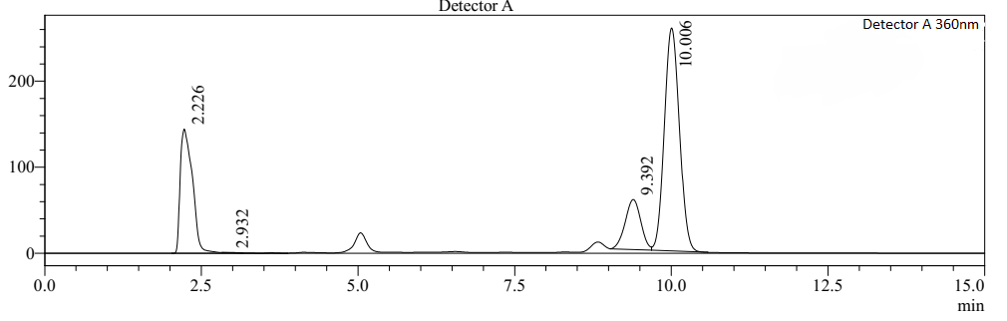
Figure: 7 Chromatogram of mixed sample solution containing 5µg/ml methotrexate and 200 µg/mL curcumin using acetonitrile and 2% acetic acid at flow rate of 1ml/min
Table: 16. Assay of Methotrexate and curcumin in bulk drug
Sr. no | Expected conc. (mg) |  | Actual conc. (mg) |  | % Assay
Sr. no | MTX | CU | MTX | CU | MTX | CU
1. | 5 | 200 | 4.86 | 197.96 | 99.68% | 99.76%
n=3

SUMMARY AND CONCLUSION
The method was developed for the simultaneous estimation of methotrexate &curcumin using RP-HPLC. Various trials were taken for the methotrexate and curcumin at certain conditions. The optimized trial included mobile phase consisting of 55:45 of ACN: 2% acetic acid and absorbance was measured at 360nm. All the parameters were validated according to the ICH guidelines and meet all the limits(Table:17).

Table: 17. Summary of validation parameters of RP-HPLC at 360nm wavelength:
Parameter | Methotrexate | Curcumin
Linear range (µg/mL) | 100-200 | 75-200
Regression coefficient (R²⁾ | 0.998 | 0.998
Limit of detection(µg/mL) | 6.095 | 6.110
Limit of quantification | 18.470 | 18.515
%Recovery | 98.59 | 99.74
Repeatability (n=6) | %RSD NMT 2 | %RSD NMT 2
Precision  Interday precision  Intraday precision | %RSD NMT 2 | %RSD NMT 2
The percentage assay of binary mixture was found to be 99.68% and 99.76% for methotrexate and curcumin respectively. The proposed HPLC method was found to be simple, precise and accurate. Hence, this method can be used for the method development and validation of Methotrexate and curcumin in bulk drug and multi-component formulation.

REFERENCES

- American Association for Cancer Research, AACR Cancer Progress Report, 2017.P.121.
- Coates A, Abraham S, Kaye SB, Sowerbutts T, Frewin C, Fox RM, Tattersall MH, On the receiving end—patient perception of the side-effects of cancer chemotherapy.,European Journal of Cancer and Clinical Oncology, 1983; 19(2):203-208.
- Khazir J, Riley DL, Pilcher LA, De-Maayer P, Mir BA, Anticancer agents from diverse natural sources, Natural product communications, 2014;9(11):195-167.
- Takeda M, Khamdang S, Narikawa S, Kimura H, Hosoyamada M, Cha SH, Sekine T, Endou H, Characterization of methotrexate transport and its drug interactions with human organic anion transporters, Journal of Pharmacology and Experimental Therapeutics, 2002; 302(2):666-669.
- Allegri P, Mastromarino A, Neri P, Management of chronic anterior uveitis relapses: efficacy of oral phospholipidic curcumin treatment. Long-term follow-up, Clinical Ophthalmology,2010; 4:1201-1207
- Vallianou NG, Evangelopoulos A, Schizas N, Kazazis C, Potential anticancer properties and mechanisms of action of curcumin,Anticancer research,2015;35(2):645-51.
- Jayaprakasha GK, Jagan Mohan Rao L, Sakariah KK,Improved HPLC method for the determination of curcumin, demethoxycurcumin, and bisdemethoxycurcumin, Journal of agricultural and food chemistry, 2002; 50(13):3668-3672.
- Moghbel, A., Zand-Moghaddamb, A., Rezaee, S., Pedram, M, High-Performance Liquid Chromatography Determination of Methotrexate in Plasma, Iranian Journal of Pharmaceutical Research, 2010; 2( 3): 149-152
- El-Hady DA, El-Maali NA, Gotti R, Bertucci C, Mancini F, Andrisano V,Methotrexate determination in pharmaceuticals by enantioselective HPLC, Journal of pharmaceutical and biomedical analysis, 2005;37(5):919-925.
- Li J, Jiang Y, Wen J, Fan G, Wu Y, Zhang C, A rapid and simple HPLC method for the determination of curcumin in rat plasma: assay development, validation and application to a pharmacokinetic study of curcumin liposome, Biomedical chromatography, 2009 ;23(11):1201-1207.
- Ramshankar YV, Suresh S, A sensitive reversed phase HPLC method for the determination of curcumin, Pharmacognosy Magazine, 2009;5(17):71-76
- Wichitnithad W, Jongaroonngamsang N, Pummangura S, Rojsitthisak P, A simple isocratic HPLC method for the simultaneous determination of curcuminoids in commercial turmeric extracts, Phytochemical Analysis, 2009; 20(4):314-319.
- Banji D, Pinnapureddy J, Banji OJ, Saidulu A, Hayath MS, Synergistic activity of curcumin with methotrexate in ameliorating Freund's Complete Adjuvant induced arthritis with reduced hepatotoxicity in experimental animals, European journal of pharmacology, 2011;668(2):293-298.
- Mishra A, Dewangan G, Singh WR, Hazra S, Mandal TK, A simple reversed phase high-performance liquid chromatography (RP-HPLC) method for determination of curcumin in aqueous humor of rabbit, Journal of advanced pharmaceutical technology & research, 2014; 5(3):147-149.
- Suguna P, Sathyanarayana B, Chandrasekhar G, Narasimhulu B, Validation of HPLC method for the analysis of methotrexate in bulk drug and pharmaceutical dosage forms,J Chem Pharm Res, 2015; 7:27-33.
- Sharma K, Giri K, Dhiman V, Dixit A, Zainuddin M, Mullangi R, A validated LC/MS/MS assay for simultaneous quantification of methotrexate and tofacitinib in rat plasma: application to a pharmacokinetic study, Biomedical Chromatography, 2015;29(5):722-732.
- Joseph SK. Simultaneous Determination of Methotrexate and Sulfasalazine in Plasma by HPLC–DAD. 2015.
- Roy M, Mohite M, Shah S, Development and validation of RP-HPLC method for thedetermination of methotrexate in bulk and pharmaceutical tablet dosages form, European Journal of Pharmaceutical and Medical Research, 2016; 3(5): 355-358
- Jahromi LP, Mohammadi-Samani S, Ashrafi H, Azadi A,A reversed-phase high performance liquid chromatography (HPLC) method for bio-analysis of methotrexate ,TIPS. 2016;2(2):101-108.
- Radha A, Ragavendran P, Thomas A, Kumar DS, A cost effective HPLC method for the analysis of curcuminiods, Hygeia.J.D.Med, 2016;8 (1) :115-120
- Panigrahi S, Hirlekar R, A new stability indicating RP-HPLC method for determination of curcumin: an application to nanoparticulate formulation, Int J Pharm Pharm Sci., 2016;12:102-107.
- Amanolahi F, Mohammadi A, Oskuee RK, Nassirli H, Malaekeh-Nikouei B, A simple, sensitive and rapid isocratic reversed-phase high-performance liquid chromatography method for determination and stability study of curcumin in pharmaceutical samples. Avicenna journal of phytomedicine. 2017;7(5):444.-447
- Hirlekar R, Bhairy S, Kmismatrao A, Development and validation of RP-HPLC method for simultaneous estimation of curcumin and piperine, Int J App Pharma, 2018;10(5):43-44
- Curcio M, Mauro L, Naimo GD, Amantea D, Cirillo G, Tavano L, Casaburi I, Nicoletta FP, Alvarez-Lorenzo C, Iemma F, Facile synthesis of pH-responsive polymersomes based on lipidized PEG for intracellular co-delivery of curcumin and methotrexate. Colloids and Surfaces B, Biointerfaces. 2018; 167:568-576.
- ICH Harmonised Tripatite Guidelines. Validation of analytical procedure: text and methodology Q2 (R1), current step 4 version, parent guidelines on methodology, November 2005.

